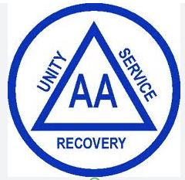

Alcoholics Anonymous - 12 Step Meetings
Meeting Schedule & AA Website
Hotlines (available 24/7)
English hotline: 650-577-1310
Spanish hotline: 650-679-2374
FAQ
What is AA?
Alcoholics Anonymous is a fellowship of people who share their experience, strength and hope with each other so that they may solve their common problem and help others to recover from alcoholism
Are there Requirements to Join?
The only requirement for membership is a desire to stop drinking
Is this free or do I have to pay to join?
There are no dues or fees for AA membership. The primary purpose of AA is to stay sober and help other alcoholics achieve sobriety
What is a 12-Step AA Program?
The 12-Step program, first developed and used by Alcoholics Anonymous, is a 12-step plan in order to overcome addiction and compulsions. The basic premise of the model is that people can help one another achieve and maintain abstinence from substances of abuse, but that healing cannot come about unless people with addictions surrender to a higher power.

AA San Mateo Website
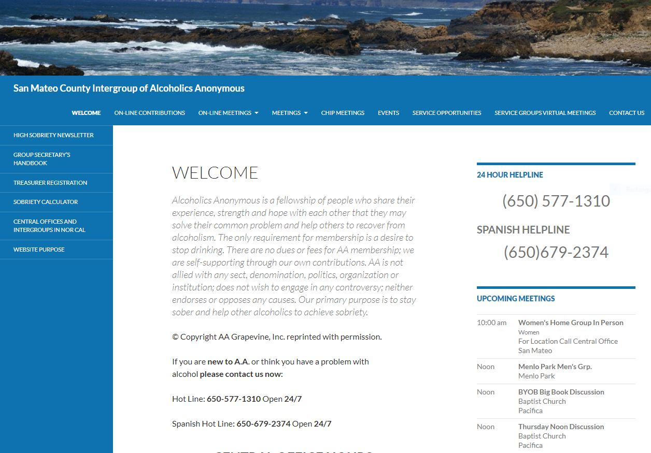

This higher power doesn’t need to be a traditional Christian version of god – it can be as simple as the community of the 12-step meetings, the universe, or a different version of a high power fit for one’s type of spirituality

